E-Heal

Phase 2

Team 4
Member Name | Member Roll # | Primary Responsibility
Shehryar Munir | 20L-1302 | Class diagram , SD1-SD5 , SD18-SD22
Fatima Siddiqui | 20L-1213 | Class diagram , SD1-SD5 , SD18-SD22
Samreen Abbas | 20L-1292 | Class diagram , SD6-SD17
Rabia Shakeel | 20L-1319 | Class diagram , SD6-SD17
Irtaza Zulfiqar | 20L-1290 | Class diagram , SD23-SD30
Muhammad Abdullah | 20L-1261 | Class diagram , SD23-SD30

Table of Contents
Table of Contents ii
1. Class Diagram 1
2. Package Diagram 2
3. Sequence Diagrams 3
3.1 Sign Up As Doctor 3
3.2 Sign Up As Patient 4
3.3 Sign Up As Laboratory 4
3.4 Sign Up As Pharmacy 5 3.5 Login 6
3.6 Search Doctor 7
3.7 Book Appointment 8
3.8 Cancel Appointment 9
3.9 Order Medicines Online 10
3.10 Maintain Health Record 11
3.11 Reschedule Appointment 12
3.12 Schedule Lab Test 13
3.13 See Scheduled Doctor Appointment 14
3.14 See Scheduled Lab Appointment 15
3.15 View Lab Report 16
3.16 View TimeTable 17
3.17 First-Aid 18
3.18 Doctor view and select Appointment 18
3.19 Approve Appointment 19
3.20 Cancel Appointment 20
3.21 Diagnose Patient 20
3.22 Request Reschedule Appointment 21
3.23 View Order 21
3.24 Approve Appointment 22
3.25 Dispatch Order 23
3.26 Upload Result 24
3.27 Enroll Actor 25
3.28 Delete User 25
3.29 Verify Doctor 26
3.30 View Enrolled Actor 26

Diagram 1

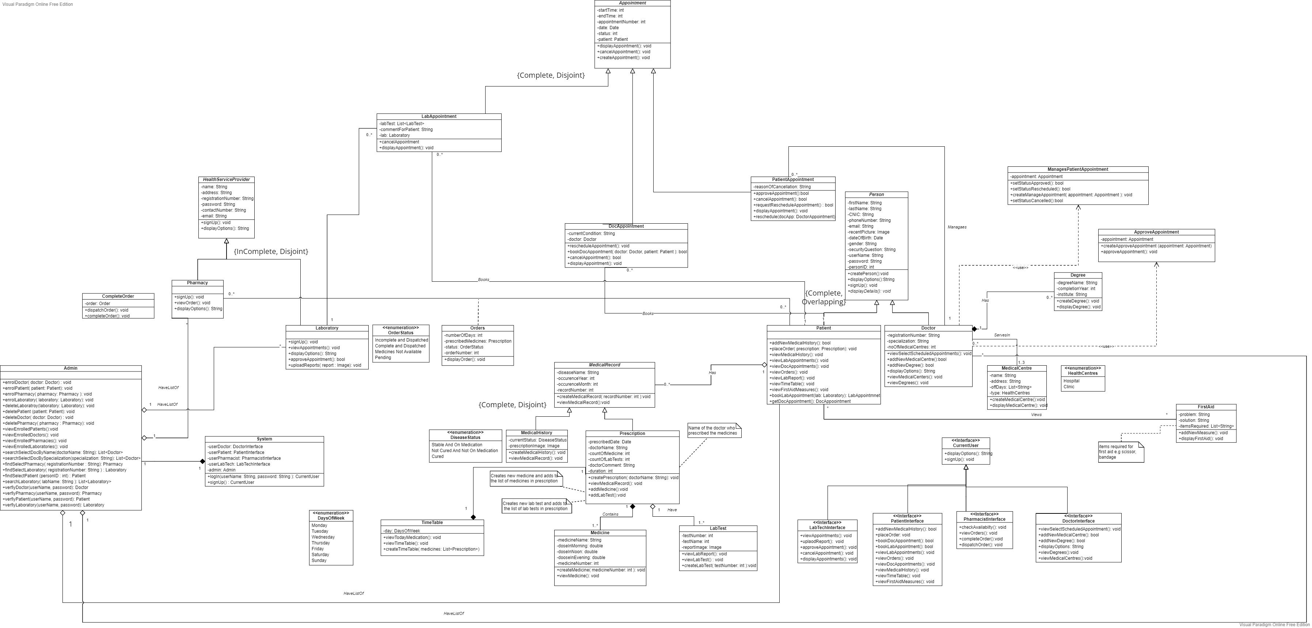

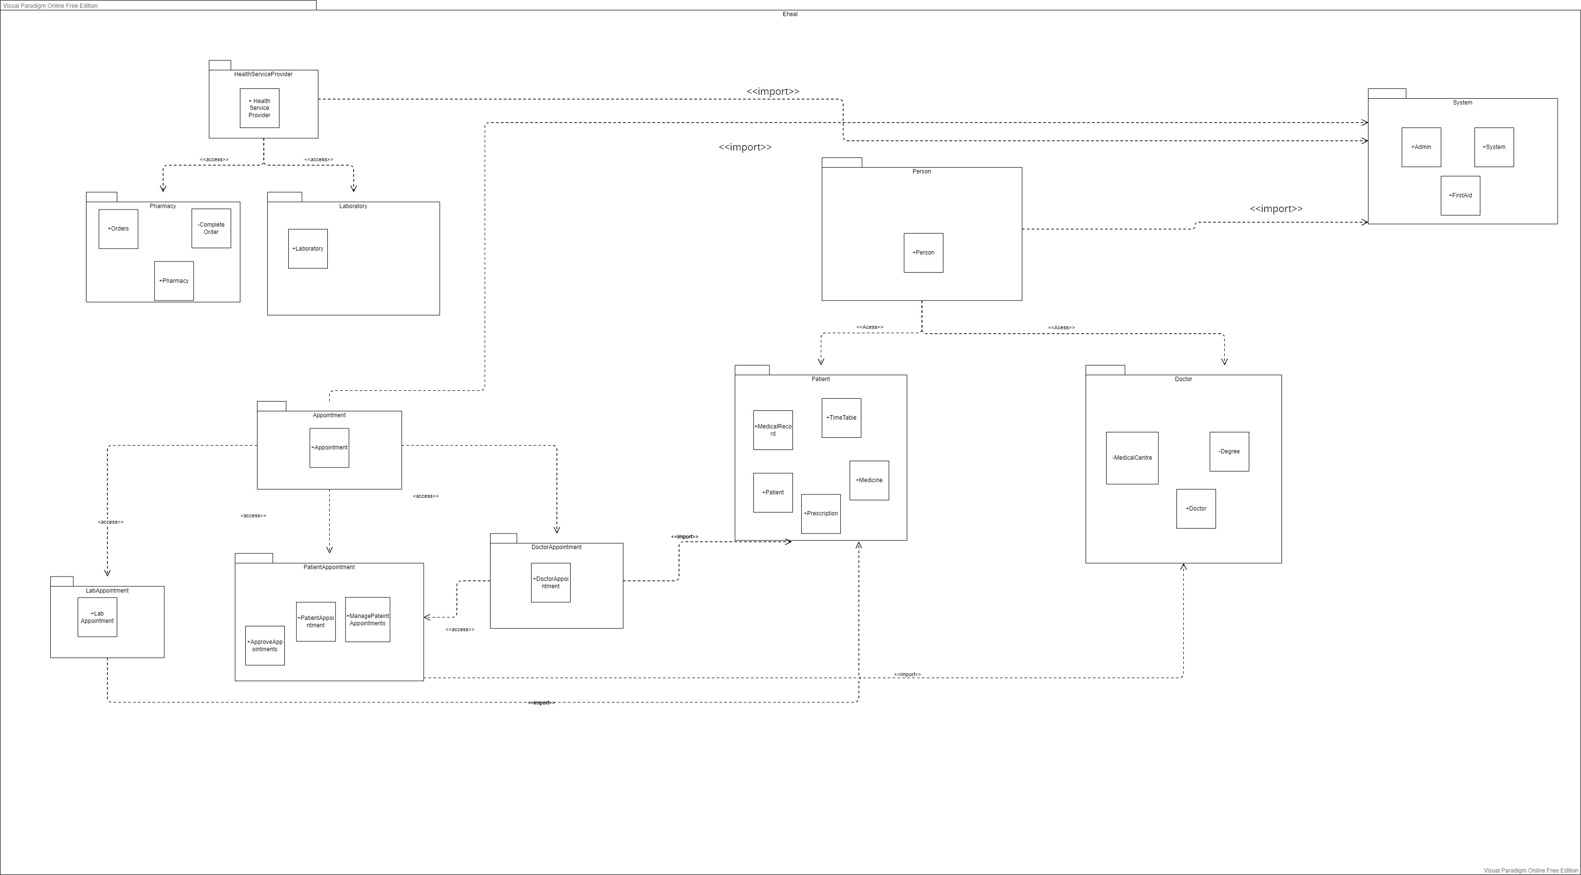

Diagram 2

Sequence Diagram

.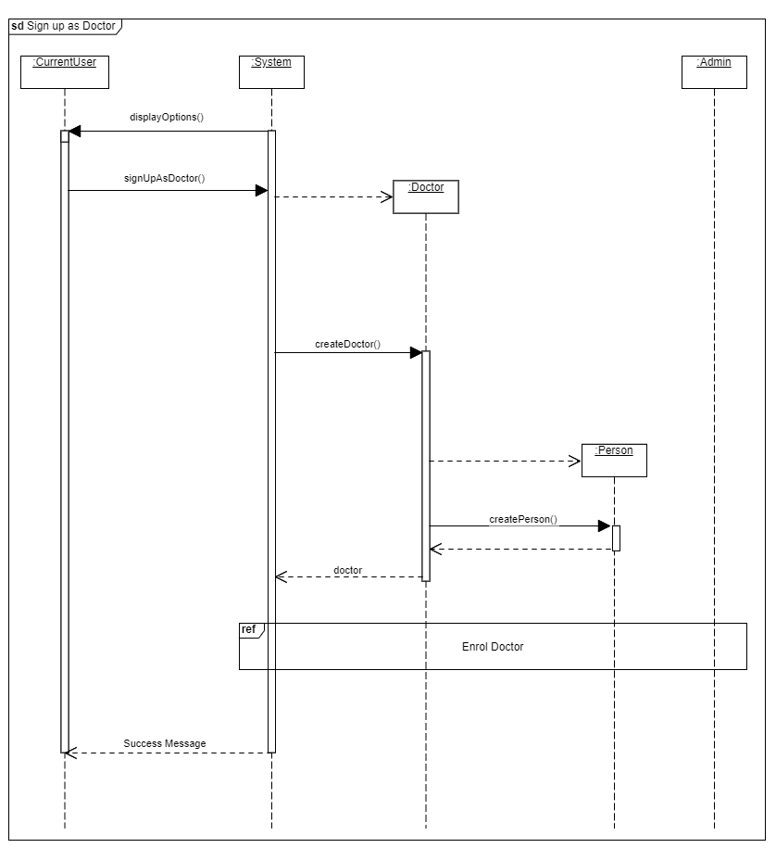

3.2

3.3

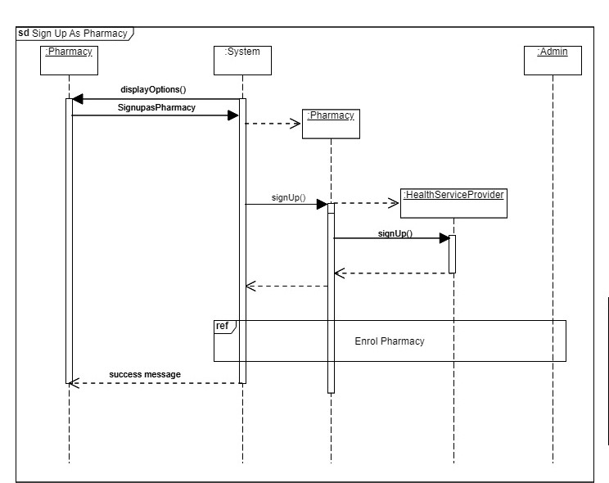

3.18

3.19

3.20

3.21

3.22

3.23

3.24

3.25

3.26

3.27

{This sequence diagram is against the use case of enrolling doctor and same sequence of steps will be performed for other actors as well}

3.28

{This sequence diagram is against the use case of delete doctor and same sequence of steps will be performed for other actors as well}

3.29

3.30

{This sequence diagram is against the use case to view enrolled doctor and same sequence of steps will be performed for other actors as well}

